Chemistry 115 Name
Dr. Cary Willard
Quiz 2A (20 points) February 12, 2009

All work must be shown to receive credit.

- (5 points) Use dimensional analysis to determine the number of dimes that are equal to 327 quarters.

- (5 points) A horse has a mass of 487 kg. What is the mass of the horse in ounces? (1 lb = 16 ounces)

- (5 points) A bottle of soda holds 345 mL of soda. How many μL (microliters) of soda does the bottle hold?

- (5 points) The ruler below is calibrated to measure centimeters. How long is the line in cm?

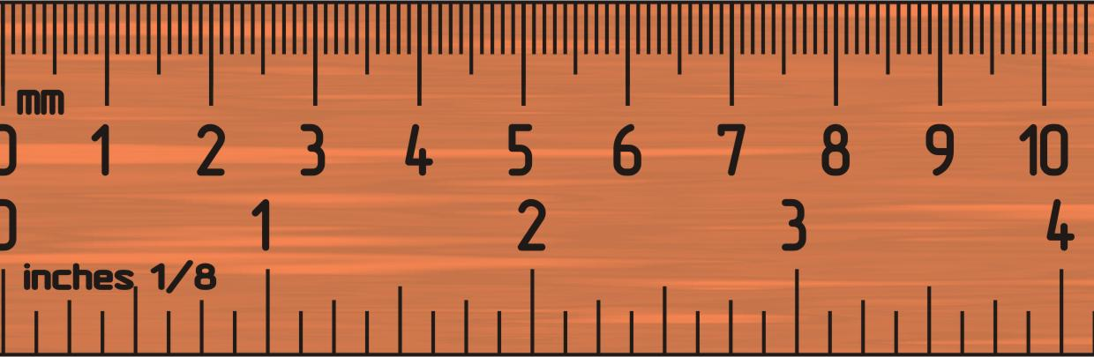
Chemistry 115 Name
Dr. Cary Willard
Quiz 2B (20 points) February 12, 2009

All work must be shown to receive credit.

- (5 points) Use dimensional analysis to determine the number of dimes that are equal to 255 quarters.

- (5 points) A horse has a mass of 571 kg. What is the mass of the horse in ounces? (1 lb = 16 ounces)

- (5 points) A bottle of soda holds 255 mL of soda. How many μL (microliters) of soda does the bottle hold?

- (5 points) The ruler below is calibrated to measure centimeters. How long is the line in cm?

